Report Assignment 3

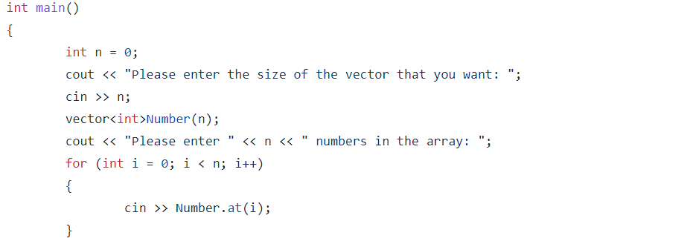

* Ask for the number size of the array and then we enter the values in accordance with the size of the vector.

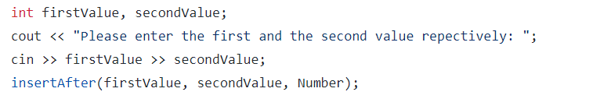

* 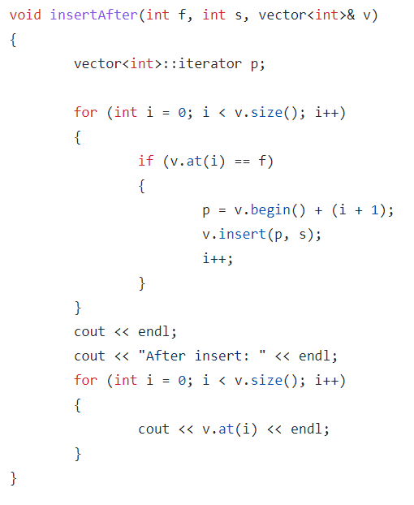We ask for the first and the second value and pass it to the insertAfter function;

In the insertAfter function we introduce an iterator and if any of the values in the vector equals to the first value, then we make the iterator point after that value and insert the second value. Then we output after the insert just for reassurance.

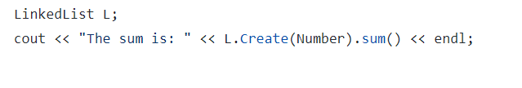Then we create an object of a Linked list and call the Create object and the sum.

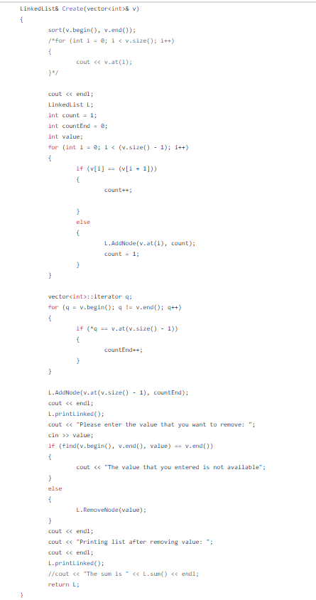jWe sort the vector ascendingly and then we count the occurrences of each value and pass it to the Add Function.

We then we ask for the user to enter a value in order to remove a node that holds that value. If it is not available then we print out an error message.

We then print the nodes and what they carry (value and occurrence)

We return L by reference to the main to just avoid the possible errors that can come with return by value in the main.

The output

